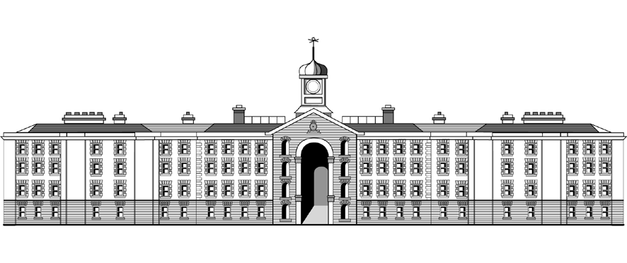
Griffith College Dublin
ASSIGNMENT TITLE SHEET
FACTULY OF COMPUTING SCIENCE

Course: MSc Big Data
Stage/Year: 1
Module: Research Methods
Semester: Semester 1
Assignment Number: Assignment 1
Date of Title Issue: 07 Nov, 2025
Assignment Deadline: 30 Nov, 2025
Assignment Submission: Upload to Moodle
Assignment Weighting: 40% of the overall module

Assignment Title
Disruptive Innovation and Literature Review

Artificial Intelligence Assessment Scale (AI AS):
This assignment is subject to AI permission option: (select all that apply)
No AI Use [ ]
AI for Planning [ Y ]
AI for Editing [ ]
AI for Support Tasks [Y ]
AI for Collaboration [ ]
Full Use of AI [ ]

If no checkbox is selected, “No AI Use” will be applied. AI Assessment Scale Framework: https://www.griffith.ie/sites/default/files/2025-05/f-6.5-ai-in-learner-assessment-policy.pdf

Please note:
- All AI generated content and process must be declared.
- Any task that is not listed as permitted may be assumed to be prohibited.
- If it is determined that a learner has used an AI tool in any way that is not permitted by the chosen level, then they will be subject to the disciplinary procedures listed in the Academic Integrity and Misconduct policy regarding the misuse of AI in assignments.

Assignment Specific AI Instructions:

The use of GenAI is accepted only to refine the idea/topic, but not accepted in the writing.

Learning Outcomes
This assignment is assessing the following programme and related module learning outcomes:

1. Critically analyse and evaluate their work and that of others.
2. Prepare and present an academic research paper based on a thorough literature review

Assessment Criteria
Assessment criteria applied to this assignment:

- Quality of documentation
- Academic approach of literature review
- Originality of the problem selected
- Self evaluation approach

Submission Instructions and Plagiarism
Plagiarism:
All work must be your own. Any cases of suspected plagiarism will be thoroughly investigated and may be brought in for VIVA. All parties involved in cases of plagiarism will receive a 0 and their student record marked accordingly. Any submission that is found to be plagiarised will receive a grade of 0 without the possibility of resubmission.

By submitting your assignment you accept that you understand what plagiarism is and that your assignment is not plagiarised in any way.

Instructions for submission:

All work must be submitted via the submission point on Moodle, email submissions not accepted.

In line with good academic practice, you must carefully acknowledge all sources including any material sourced from other students. You must fully reference the source(s) of such work so that examiners may assess the value of your contribution. You may be required to explain/present your submission as part of the work. For that reason it is important that you understand what you present.

The use of AI should be clearly described at the end of your submission

Submission format: Submit to moodle, only ONE .pdf file is accepted.

Submission naming convention: e.g. firstname_studentnumber_short_title.pdf

Penalties
Late Penalties:
Standard penalties will be applied to work that is submitted late, as per faculty guidelines.

Presentation Instructions
Instructions for presentation:

Show your face while talking
Use appropriate slides (not scrolling over document)

You might randomly be selected for live presentation (VIVA)

Research Paper

You are required to write a research paper that is not less than 1200 words and not more than 1400 words (excluding title and references). The purpose of this paper is to engage you an in-depth research project – employing critical thinking – in the field of emerging disruptive innovations (technologies and products), their impact and the relevant future trends. As part of this assignment, you are required to do literature review and are required to present your own / original views.
As discussed in the first few weeks in-class discussions, this is a broad field in which many exciting developments are occurring. The topic selection is up to you; however, it should be within the field of your masters (Big Data, Digital Media, …). Be creative in your approach to your topic. If you are unsure, or have a question or need to further discuss this, please drop me an e mail.
Organize and format your paper carefully. Please give an abstract at the beginning. Include an introduction with a clear description of “what” is your topic. Do include the details that “why” you have selected this topic (motivation); discuss in detail the origin, history and impact of the selected technology, and the future trends. Along with the information gathered as part of the literature review and from your research, there should be a recognizable element of your original thoughts and views. Connect your ideas together with good transitions from paragraph to paragraph. Write clearly and proofread carefully. At the end of the conclusion section, and before the bibliography, please indicate the word-count. Following is a suggested outline:
Title of the Paper
Author’s details (name, cohort, e mail)
Abstract
I. Introduction to the topic
- What is the technology under discussion?
- Why is it an important topic at this time?
(Is it currently a hot topic? Has it been a hot topic for some time? Is it a new technology / product that has just come on the scene? Do give information from the literature review and highlight your take on this. Make it sound interesting.)
- Give the reader an idea what this paper is about and how it is structured by stating: “This paper will…” and “next section presents…, section xx discusses …… then concluding remarks are presented in section ….”.
II. Historical perspective on the topic
- What did your extensive research / literature review reveal about this topic?
- Where did this topic/technology/idea originate, and what is its history?
- Organize your review of the info so that you address several topics in an orderly fashion.
- Try to address the issue from both the consumers’/users’ and the producers’/developers’ point of view.
III. Current perspectives on the topic
- What is going on right now with this issue/topic?
- Why should we be interested in this topic today?
- What are the positions of the competing interests?
- What are the forecasts for the future of the relevant technologies?
Make a case for the disruption that this Technology is / will cause.
IV. Conclusion
- Brief restatement of the ideas and opinions presented
- Brief summary of what you found, and why it is important to study it
References List / Bibliography

You can certainly use the Internet for your research but remember that it is sometimes difficult to determine the credibility of the information on a website. The use of GenAI is accepted only to refine the idea/topic, but not accepted in the writing. Carefully cite the credible sources – books, academic, conference and journal papers and articles, and technical documents – by using IEEE referencing systems. You must use at least 10 credible sources in writing your paper – more would be better. Please provide the word count of the paper at the end of the conclusion section.
You are required to prepare the assignment using referencing and bibliography tools of typing and editing using LaTeX Document Preparation System. You are required to use the report document template (please see appendix). It is recommended you use Overleaf Online LaTeX Editor available at: https://www.overleaf.com/
You are required to prepare a 6-minute video strictly following the below timeline: Introduce the idea (60 Seconds); what disruptions it has or will cause (120 seconds); Use the rest of time to evaluate your paper against Universal Intellectual & Academic Standards outlined in the Self-Assessment Sheet.

Notes:
- One of the main objectives of this assignment is to assess your ability to conduct literature review. That is why, intext referencing & citations and a relevant bibliography are an essential part of this assessment. Make sure you complete three checks outlined in the brief.
- Outline to perform self-assessment of your paper are provided in this brief and discussed in the class. You are required to compete this form and submit it with the assignment.
- You have to write a brief reflective statement (400 words) about your paper evaluating it against the Universal Intellectual Standards.
- Your are required to make a 6 minute video presentation
- You might be invited for a brief in-person meeting and viva to evaluate the quality and originality of your work.
- You are required to pass it through “Turn-it-in” on the Moodle and make sure that the similarity index is less than 30.
- There will be two links on Moodle.
- RM Assignment 1: Turn-it-in Link
  - Use this link to pass your writeup through Turn-it-in to check similarity index. Clearly specify this similarity index at the end of your paper.
- RM Assignment 1: Final Paper Submission Link
  - Use this link to submit the final assignment document. Please submit one document file that must include assignment submission sheet, research paper with bibliography, self-assessment and reflective statement, this should be in PDF created by LaTeX. Clearly specify final Turn-it-in similarity index just after conclusion at the end of your paper, and in the self-assessment section
- RM Assignment 1: Video Submission Link
- PLEASE DO NOT SUBMIT ZIPPED FILES.

Research Methods
Assignment 1 (Research Paper)
Self-Assessment sheet
No | Category | Marks Allocated | Marks Obtained | Comments (justify the marks)
1 | Clarity  (Idea) | 15
2 | Accuracy | 10
3 | Precision | 10
4 | Relevance | 5
5 | Depth | 20
6 | Breadth | 20
7 | Logic | 10
8 | Significance | 5
9 | Fairness | 5
10 | Total | 100
11 | Turn-it-in Similarity Index
 | Check | Check Details | Yes / No | Comments
 | Check-1 | Intext Referencing / Citations
 | Check-2 | Bibliography
 | Check-3 | Intext Referencing Matches Bibliography
 | Check-4 | Reflective Statement

MSc Research Methods
Assignment 1 (Research Paper)
Reflective Statement (approximately 400 words)

Appendix
Latex Document Template

\documentclass[a4paper]{report}
\usepackage[top=1in, bottom=1in]{geometry}
\usepackage[utf8]{inputenc}

\title{Research Methods \\ \vspace{2cm} \textbf{Assignment 1} \vspace{2cm}}
\author{Submitted to Griffith College \\ By Your Name \\ student number \\ email\vspace{4cm}}
\date{December 2024}

\begin{document}

\maketitle
\chapter{Part A: \\ \LARGE Research Paper\\ Your Topic Title}

\textbf{Word count is xxxx words}

\chapter{Part B: \\ \LARGE Self-Assessment Sheet}

\chapter{Part C: \\ \LARGE Reflective Statement}

\textbf{Word count is xxxx words}

\bibliographystyle{ieeetr}
\bibliography{references}
\end{document}

